**What is Visualforce?**

Visualforce is a framework that allows developers to build sophisticated, custom user interfaces that can be hosted natively on the Lightning platform. The Visualforce framework includes a tag-based markup language, similar to HTML, and a set of server-side “standard controllers” that make basic database operations, such as queries and saves, very simple to perform.

In the Visualforce markup language, each Visualforce tag corresponds to a coarse or fine-grained user interface component, such as a section of a page, a related list, or a field. The behavior of Visualforce components can either be controlled by the same logic that is used in standard Salesforce pages, or developers can associate their own logic with a controller class written in Apex.

**Sample of Visualforce Components and their Corresponding Tags**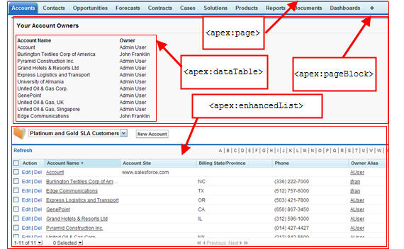

What is a Visualforce Page?

Developers can use Visualforce to create a Visualforce page definition. A page definition consists of two primary elements:

* Visualforce markup
* A Visualforce controller

Visualforce Markup

Visualforce markup consists of Visualforce tags, HTML, JavaScript, or any other Web-enabled code embedded within a single <apex:page> tag. The markup defines the user interface components that should be included on the page, and the way they should appear.

# Which Permissions are Required for Visualforce Development?

Visualforce development requires various permissions, depending on the specific activity.

| **User Permissions Needed** | |
| --- | --- |
| To enable Visualforce development mode: | “Customize Application” |
| To create, edit, or delete Visualforce pages: | “Customize Application” |
| To create and edit custom Visualforce components: | “Customize Application” |
| To edit custom Visualforce controllers or Apex | “Author Apex” |
| To set Visualforce page security: | “Manage Profiles and Permission Sets” |
| To set version settings for Visualforce pages: | “Customize Application” |
| To create, edit, or delete static resources: | “Customize Application” |
| To create Visualforce Tabs: | “Customize Application” |

# How is Visualforce Architected?

All Visualforce pages run entirely on the Lightning platform, both when a developer creates the page, and when an end user requests a page, as shown in the following architecture diagrams.

**Visualforce System Architecture - Development Mode**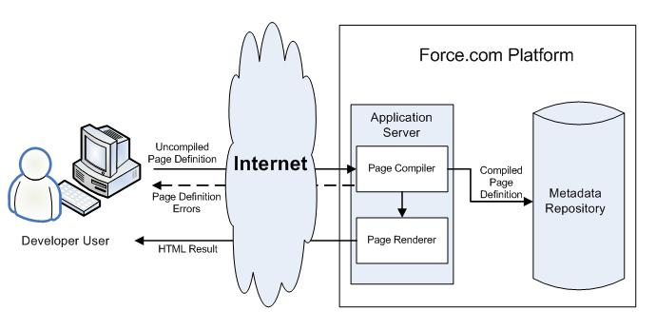

When a developer finishes writing a Visualforce page and saves it to the platform, the platform application server attempts to compile the markup into an abstract set of instructions that can be understood by the Visualforce renderer. If compilation generates errors, the save is aborted and the errors are returned to the developer. Otherwise, the instructions are saved to the metadata repository and sent to the Visualforce renderer. The renderer turns the instructions into HTML and then refreshes the developer's view, thereby providing instantaneous feedback to the developer for whatever changes were made in the markup.

The architecture diagram below shows the process flow when a non-developer user requests a Visualforce page. Because the page is already compiled into instructions, the application server simply retrieves the page from the metadata repository and sends it to the Visualforce renderer for conversion into HTML.

**Visualforce System Architecture - Standard User Mode**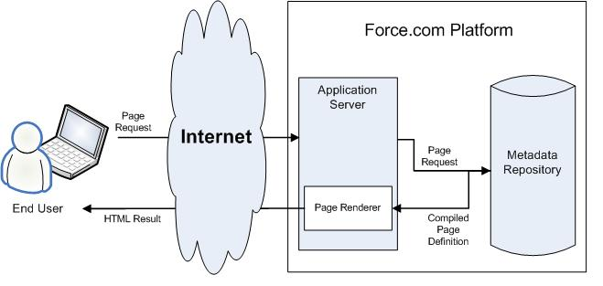

# How is Visualforce Architected?

All Visualforce pages run entirely on the Lightning platform, both when a developer creates the page, and when an end user requests a page, as shown in the following architecture diagrams.

**Visualforce System Architecture - Development Mode**

When a developer finishes writing a Visualforce page and saves it to the platform, the platform application server attempts to compile the markup into an abstract set of instructions that can be understood by the Visualforce renderer. If compilation generates errors, the save is aborted and the errors are returned to the developer. Otherwise, the instructions are saved to the metadata repository and sent to the Visualforce renderer. The renderer turns the instructions into HTML and then refreshes the developer's view, thereby providing instantaneous feedback to the developer for whatever changes were made in the markup.

The architecture diagram below shows the process flow when a non-developer user requests a Visualforce page. Because the page is already compiled into instructions, the application server simply retrieves the page from the metadata repository and sends it to the Visualforce renderer for conversion into HTML.

**Visualforce System Architecture - Standard User Mode**